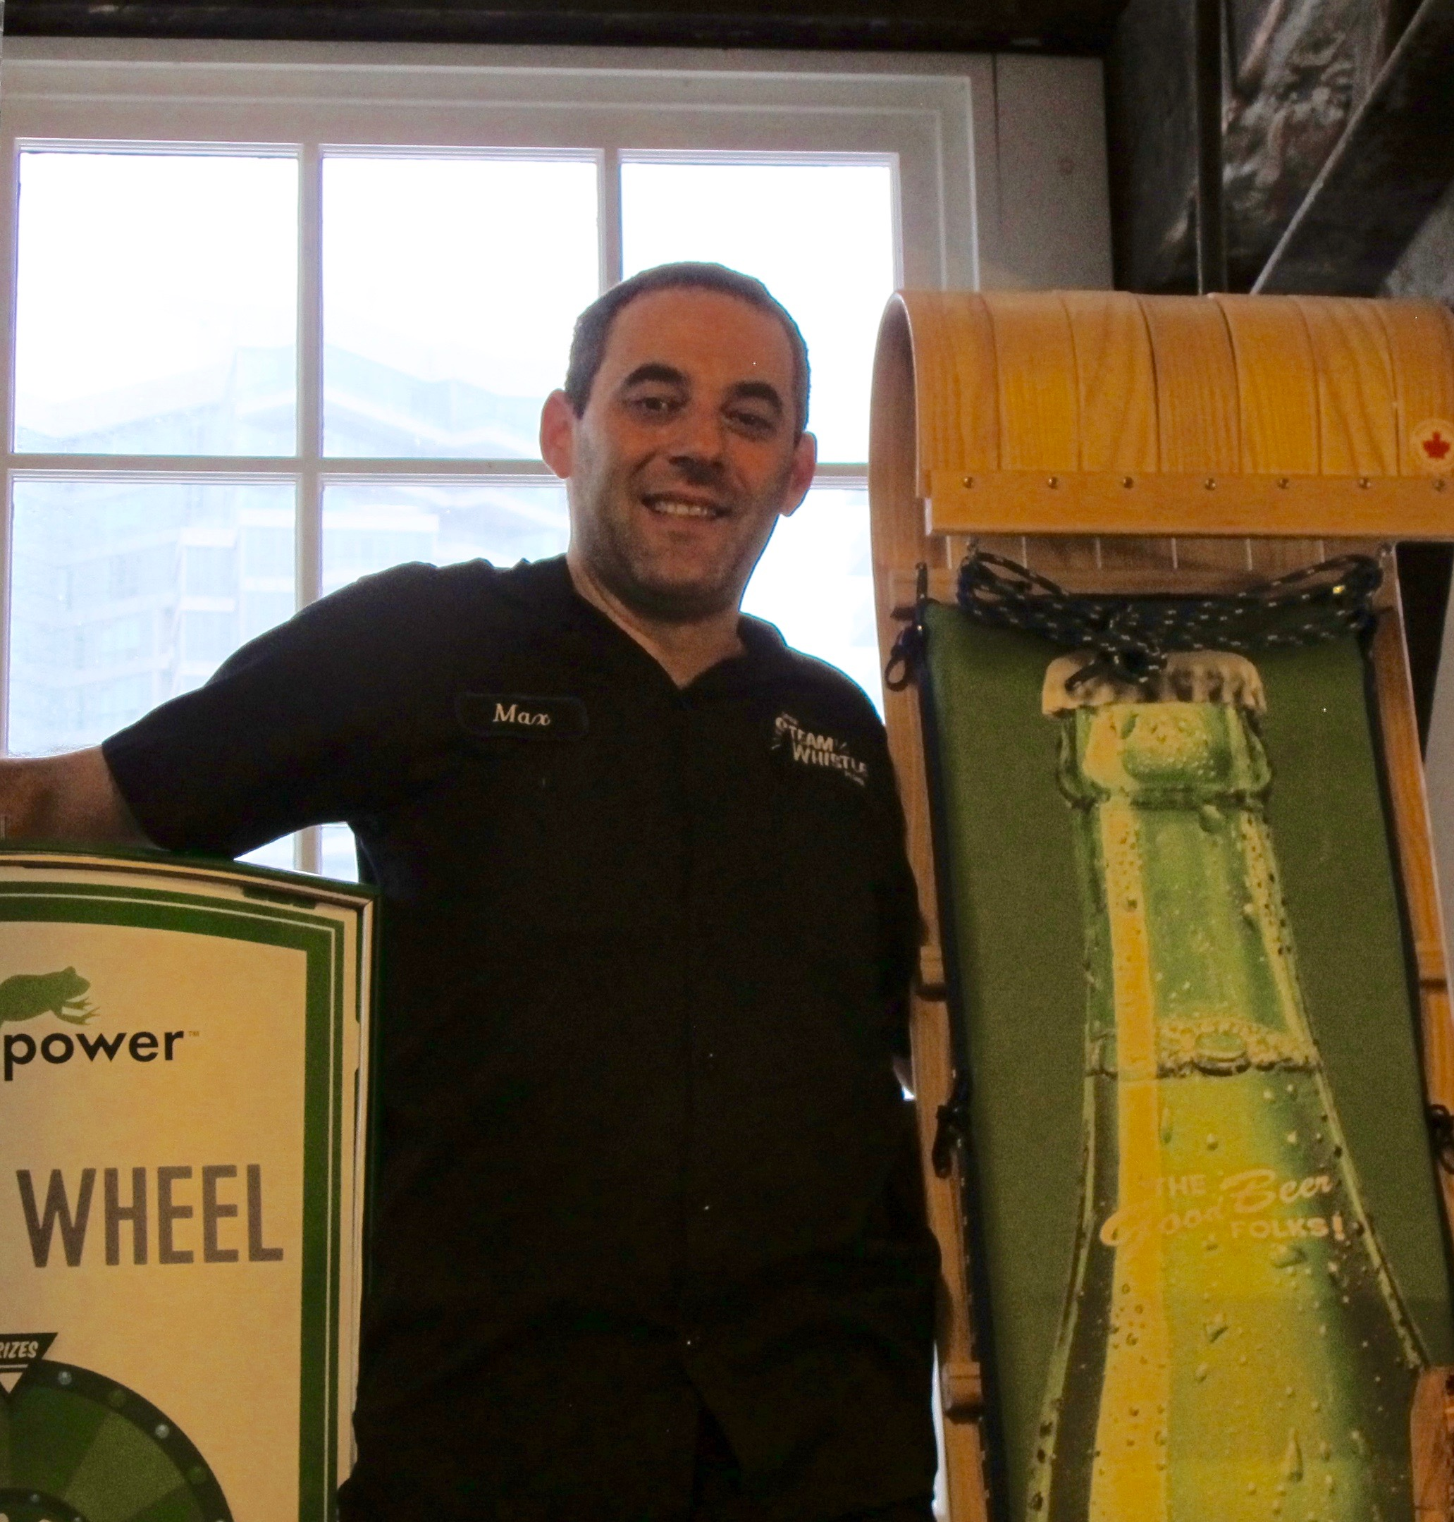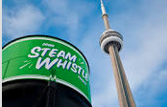

**Do you have advice for riding in the winter?**

Don’t ride on thin tires: small tires will get caught in the streetcar tracks.

And, when it’s wet out, I’ll be very cautious going over metal because it gets slippery. Don’t make a turn on the metal—go straight against it.

*In terms of clothes and gear:* all people have pressure spots--for me it’s my ears. Another cold spot is the tips of your fingers: think about it: if your hands are over the handlebars they’re constantly receiving the brunt of the cold and wind.

*A good tip: wear latex gloves under your winter mitts. “Your hands will be sweating by the time you get home.”*

*Tip two: if your lungs are inhaling too much cold air, a scarf or balaclava can help filter, and warm up, your lungs.*

*Tip three: keep your top half warmer as your legs will warm up riding.*

*Finally, invest in a back fender to keep your backside mud-free. His buddies call it the dreaded, ‘poo streak.’*

**Steam Whistle giveaway**

Some of his friends think he’s crazy cycling to work in the winter (add to that cycling in downtown Toronto!)

Luckily, Max Walton, the packaging line production supervisor for Steam Whistle Brewery in Toronto is not susceptible to cold, or so he says. Freaky genes aside, why does he bother?

“I’m a little boy at heart, but I’ve never gotten into video games, but I feel like I’m flying a space ship on a bike through the city, passing waiting cars. ‘You guys (the drivers) have to wait four more traffic lights and I’ll be home by then!’

Commuting, and biking in Toronto, is the best way to get around in the city, says Max. “The traffic is just terrible—we’re packing more people into the core all the time.”

After parking my bike outside Steam Whistle Brewery, the site of the former CP Railway repair station, and across the street from the CN Tower, I sit down with Max to get advice about safe and happy commuting through Toronto’s winter.

# Meet Max!

Cycling Gear Giveaway!

**Compared to other countries—what is our relationship between cars and drivers in the city of Toronto?**

Europe is designed for bikes and they added cars after; that’s not the case here.

We have a more strained relationship –again it’s because we’re behind the times: the city hasn’t adjusted to biking earlier.

In other cities, drivers are more aware of cyclists. I just assume every driver is the worst driver in the world. I don’t treat anyone like they see me. I’ve had some mishaps -- some my own fault if I’m going too fast or being too cocky. I flipped over car doors a few times (from parked cars), but nothing major.

I respect anyone who is afraid of getting hit (and not wanting to ride in Toronto), but, if you are afraid of biking then you will get hit. Meaning, you have to be confident, safe and aware. I will never wear headphones: you need to hear little things. For example, you can still hear a car engine make sounds after the car is turned off –that says to me that maybe the driver hasn’t exited the car yet.

And, don’t always search for a turn signal. Many drivers don’t use them. Instead, look at the front wheels to see if the car is turning.

***Toronto’s best routes; worst routes?***

I’m not afraid of cars, but I also don’t merge with traffic. I also don’t like segregated bike lanes--it gives bikers a false sense of security. Just always be aware. *He adds that Toronto isn’t really a bike-friendly town.* “We’re a little behind the schedule.

Richmond and Adelaide Streets are decent the whole way and have a segregated bike path. Lakeshore you can bike all the way to BC or Nova Scotia (part of The Waterfront Trail, and TransCanada Trail), but in wintertime ice and snowdrifts accumulate from the lake wind. I choose the main streets as they’re cleaned most frequently (I try to stay on quiet side streets). I avoid Queen Street at all costs—it’s one of my least favourites.

***When don’t you ride in the winter?***

There’s maybe a week or two that I just can’t. It’s messy. If too much snow has accumulated on the street, the snow plows pile it up, and pushes it into a slushy pile on the side of road, and that’s when the bike lanes get trashed.

I’ll take a couple days off until it melts; I also don’t ride if it’s super icy.

**Bike shops you like**

Toronto’s iconic Dukes Cycle on Queen Street is his shop of choice for big repairs. www.dukescycle.ca

Closer to his home he also visits Rideawaybikes [www.rideawaybikes.ca](http://www.rideawaybikes.ca).

**Does Toronto have a bike mentality?**

I wish more people would ride. Consider that to get anywhere in the city, someone might spend $30 to get there (in a cab)—or wait for limited public transport--but if they use rental bikes BIXI, it’s so much less. I hope with more bikes lanes being added that they (the city) make it less convenient for cars and then more people will start biking.